**Basal Salt Composition, Cytokinins, and Phenolic Binding Agents Influence *in vitro* growth and *ex vitro* establishment of *Magnolia* 'Ann'**

**J. Kevin Parris1*, Darren H. Touchell2, Thomas G. Ranney2, and Jeffrey Adelberg1**

1Clemson University, Dept. of Environ. Horticulture, 164 Poole Agricultural Center, Clemson, SC 29634,

*Fax: + 1 864 592 4708, *E-mail: parrisk@sccsc.edu

2NC State University, Dept. of Horticultural Science, 455 Research Dr., Mills River, NC 28759

**Abstract**

*In vitro* growth responses of *Magnolia* ‘Ann’ to basal salt composition, cytokinins, and phenolic binding agents were investigated in a series of experiments to refine micropropagation protocols. Combinations of Murashige and Skoog (MS), half-strength MS, Lloyd and McCown Woody Plant Medium (WPM), Driver and Kuniyuki (DKW) and Blaydes basal salts in conjunction with activated charcoal (AC) or polyvinylpyrrolidone (PVP) were evaluated as a multiplication media. In a second experiment 6-benzylaminopurine (BAP), *meta*-Topolin (*m*T), or 6-(γ,γ-dimethylallylamino) purine (2iP), at 2, 4 or 8 µM were investigated to optimize cytokinin concentration. Murashige and Skoog basal medium (MS), supplemented with 2 µM benzylamino purine with no phenolic binding agent was an optimal multiplication medium that yielded a 3.2× multiplication rate over an 8-week period. For rooting, microcuttings were cultured on half-strength MS media supplemented with 0, 5,10 or 20 µM indolebutyric acid (IBA) with or without AC. Media containing AC produced elongated microcuttings suitable for rooting and *ex vitro* establishment. Microcuttings cultured *in vitro* on a medium supplemented with AC also had higher *ex vitro* rooting, compared to those without AC regardless of *in vitro* indolebutyric acid concentration.

**Key Words:** basal salts, cytokinins, micropropagation, phenolic binding agents, polyploidy, tissue culture.

**Running Title:** *In vitro* propagation of *Magnolia*

**INTRODUCTION**

The genus*Magnolia* L. consists of over 250 species (Figlar and Nooteboom, 2004) and numerous hybrids and cultivars that can be cultivated in temperate and tropical climates worldwide. The diverse ornamental traits make the genus appealing for landscape use and breeding new cultivars. *Magnolia* [*liliiflora* ‘Nigra’(4*x*)× *stellata* ‘Rosea’(2*x*)] ‘Ann’ (NA 28344; PI 326570) is a member of the “Little Girl” series of magnolias that have become very popular (USNA 2003). *Magnolia* ‘Ann’ is characterized by a desirable combination of traits including prolific and remontant flowering and a shrub-like form. Parris et al. (2010) confirmed *M*. ‘Ann’ to be a triploid (2*n* = 3*x* = 57) and is therefore sterile. *In vitro* regeneration procedures may be an efficient means for rapid, large-scale production as well as providing a platform for *in vitro* chromosome doubling that may restore fertility and allow for future breeding efforts.

Previous micropropagation studies on *Magnolia* sp. focused on conservation purposes which included *M. acuminata* var. *cordata* (Michx.) Sarg.(Merkle and Wiecko 1990, Merkle and Wilde 1995), *M. dealbata* Zucc. (Mata-Rosas et al. 2006), *M. denudate* Desr.(Bi et al. 2002)*, M. fraseri* Walt. (Merkle and Wiecko 1990, Merkle and Wilde 1995), *M. macrophylla* Michx.(Merkle and Watson-Pauley 1993, Merkle and Wilde 1995)*,* *M. obovata* Thunb. (Kim et al. 2007), *M. officinalis*Rehd. and Wilson.(Tong et al. 2002), *M. pyramidata* Bartram. (Merkle and Watson-Pauley 1994, Merkle and Wilde 1995), *M. sieboldii* Koch. (Lu et al. 2008), *M. sinicum* Law. (JunLi and Mingdong 2007), and *M. virginiana* Linn. (Merkle and Wiecko 1990, Merkle and Wilde 1995). However, less work has been done on micropropagation of ornamental *Magnolia* taxa with the exception of *M.* × *soulangeana* Soul.-Bod. (Maene and DeBergh 1985, Kamenicka and Lanakova 2000, Marinescu 2008), *M*. *grandiflora* L. (Sakr et al. 1999, Tan et al. 2003), *M. delavayi* Franchet. (Luo and Sung 1996). *M. stellata* Sieb. Zucc., and the hybrids ‘Elizabeth’ and ‘Yellow Bird’ (Beidermann 1987). These studies indicated basal salt composition and plant growth regulators were important factors influencing *in vitro* propagation of magnolia.

Media comprised of MS basal salts and vitamins, (Murashige and Skoog 1962) have been widely used for *in vitro* propagation of magnolia (Beidermann 1987, Marinescu 2008). Merckle and Watson-Pauley (1993, 1994) used Blaydes Modified Basal Medium (Blaydes 1966) for somatic embryogenesis of *Magnolia* sp. Several alternative media compositions such as DKW basal salt mixture (Driver and Kuniyuki 1984) and Woody Plant Medium (WPM) (Lloyd and McCown 1981) have been tested with a wide range of woody plant species with only limited investigations with *Magnolia* (Kamenicka and Lanakova 2000).

While several cytokinins have been used to induce shoot proliferation, 6- benzylaminopurine (BAP) has been most often used for magnolia. For *Magnolia* ×*soulangeana,* BAP was shown to produce greater shoot proliferation than 6-(γ,γ-dimethylallylamino) purine (2iP), kinetin, or thidiazuron (Marinescu 2008). However, BAP has been shown to induce hyperhydricity, reduce shoot quality, and inhibit rooting in some taxa (Bairu et al. 2007, Amoo et al. 2011). *Meta*-topolin (*m*T), a naturally occurring cytokinin similar in structure to BAP, has not been associated with hyperhydricity (Bairu et al. 2007, Werbrouck et al. 1996), and has been effective for micropropagation of many species (Meyer et al., 2009, Amoo et al., 2011).

Micropropagation of magnolia’s has been reported to be difficult due to the presence of phenolic substances (JunLi and Mingdong 2007, Sakr et al. 1999). Activated charcoal (AC) and polyvinylpyrrolidone (PVP) are used commonly in media to bind phenolics. Ascorbic acid was effective in micropropagation of *Magnolia* ×*soulangeana (*Radomir and Radu 2008) and may reduce oxidative processes that lead to phenolic accumulation. While AC and PVP have not been evaluated for *Magnolia,* they have been effective phenolic binding agents (PBAs) used in micropropagation of many plant species (Roy 1991, Thomas 2008). Therefore, the objective of the current study was to evaluate a range of basal media compositions, cytokinins, and phenolic binding agents, to improve *in vitro* growth conditions for *M.* ‘Ann’ as a means for micropropagation and future ploidy manipulation. *Ex vitro* establishment protocols were also examined to insure a viable mechanism exists to maintain germplasm or for commercial production.

**MATERIALS AND METHODS**

**Plant Material and Culture Conditions**

Apical and axillary bud explants were used to initiate cultures. Actively growing shoots were collected from containerized plants maintained in a glasshouse and rinsed under tap water for 4-h. Explants were surface-sterilized in a 20% (v/v) Ultra Clorox (6.15% NaOCl) solution containing two to three drops of Tween 20, and periodically agitated for 17 min before 3 rinses in sterile distilled water for 5 min each. Explants were cultured on regeneration media consisting of MS basal salts and vitamins supplemented with 2 µM BAP, *myo*-Inositol at 100 mg.L-1, 2-(N-Morpholino) ethanesulfonic acid (MES) monohydrate at 100 mg.L-1, sucrose at 30 g.L-1. Media were solidified with 0.8 % agar and adjusted to a pH of 5.75 ± 0.03. Regenerated shoots were used as stock cultures for all experiments and maintained by transferring to fresh regeneration media every 4 to 6 weeks and incubated under standard culture conditions [23 ± 2 °C and a 16-h photoperiod of 30 µmol m-2s-1 (400-700 nm) provided by cool-white fluorescent lamps].

**Experiment 1 - Media Composition and Phenolic Binding Agents**

Effect of basal media composition was tested with five basal salt compositions and vitamins (MS, ½ MS, WPM, Blaydes, and DKW), in factorial combination with phenolic binding agents (control, AC at 1 g.L-1, or PVP at g.L-1). All media were supplemented with sucrose at 30 g.L-1, 2 µM BAP, *myo*-inositol at 0.1 g.L-1, MES monohydrate at 1 g.L-1, and solidified with 0.8% agar. Twenty five mL of media was dispensed to 180-mL glass jars. Five microcuttings, ≈ 15 to 20 mm long were placed in each jar and incubated under standard culture conditions as described above. Each treatment consisted of six replicates (jars) and five subsamples (microcuttings) each for a total of 30 shoots per treatment. All treatments were arranged in a completely randomized design. After 8 weeks, individual microcuttings were scored for shoot number, shoot length (longest shoot) and root number. Fresh and dry weights were determined for the combined 5 shoots for each replicate. To determined dry weights, material was dried at 80 °C for 4 d.

**Experiment 2 - Cytokinin Concentration and Activated Charcoal**

To investigate the interaction between cytokinins and AC, the effect of three cytokinins (BAP, *m*T, and 2iP) at three concentrations (2, 4, or 8 µM) with or without at 1 g.L-1 AC was evaluated in a completely randomized design with a factorial arrangement of treatments. Based on the results of Experiment 1, the basal media consisted of MS basal salts and vitamins, sucrose at 30 g.L-1, myo-Inositol at 0.1 g.L-1, MES monohydrate at 1 g.L-1 and solidified with 0.8% agar. The experiment consisted of six replicates (jars) per treatment and five subsamples (microcuttings) per replicate, arranged in a completely randomized design under standard culture conditions (as described above). After 8 weeks, individual microcuttings were scored for shoot number, shoot length (longest shoot) and root number. Fresh and dry weights were determined for the combined 5 shoots for each replicate. To determined dry weights, material was dried at 80 °C for 4 d.

Data for both studies were subjected to analysis of variance procedures (Proc GLM, SAS version 9.1; SAS Institute, Cary, NC). Means were separated by Fisher’s least significant difference (LSD) at *P* < 0.05.

**Experiment 3 - Root Initiation and Acclimatization**

Effects of IBA concentration in combination with AC on rooting was investigated. Stock cultures were maintained as previously described. Unrooted microcuttings, ≈ 15-20mm long, were subcultured onto media consisting of ½ MS basal salts and vitamins, sucrose at 30 g.L-1, myo-inositol at 0.1 g.L-1, MES monohydrate at 0.1 g.L-1, varying concentrations of IBA (0, 5, 10, or 20 µM), AC (0 or 1 g.L-1), and solidified with 0.8 % agar. The experiment consisted of six replicates (jars) per treatment and five subsamples (microcuttings) per replicate, arranged in a completely randomized design. After 6 weeks, microcuttings were evaluated for number of roots and root length produced*.* Microcuttings then were carefully rinsed to reduce transfer of sucrose to the soilless media. Microcuttings were inserted with one leafless node placed below the surface of the media (2 : 1, peat : vermiculite, v/v) in 50-cell trays in a randomized block design and placed under intermittent mist (10 s duration at 10 minute intervals). Data was collected on number of microcuttings rooted, roots per plant, lateral root number, and number of new leaves at 6 weeks *ex vitro*. Data were subjected to analysis of variance procedures and regression analysis (Proc GLM, SAS version 9.1; SAS Institute, Cary, NC).

**RESULTS AND DISCUSSION**

**Experiment 1 - Media Composition and Phenolic Binding Agents**

Media composition, PBA, and their interactions had significant effects on shoot number, root number, fresh weight (FW), and dry weight (DW) (*P* < 0.01). Shoot length was affected by media composition and PBA main effects (*P* < 0.01), but not by their PBA interactions (Table 1.).

High shoot proliferation was observed on MS, ½ MS, WPM and DKW with PVP or without PBA (2.6 to 3.2 shoots per microcutting). In contrast, use of AC as a phenolic binding agent with these four media compositions reduced shoot formation (1.1 to 1.2 shoots per microcutting). Microcuttings cultured on Blaydes medium, showed reduced shoot proliferation regardless of phenolic binding agent used. Similar interactions between PBA and media compositions influenced FW and DW. Fresh weights on ½ MS, MS and DKW without phenolic binding agents were relatively high (8.1, 5.6, and 2.9 g, respectively) but declined when AC was added to the medium (2.1, 2.8 and 3.0 g respectively). Lowest FW was observed on WPM and Blaydes medium regardless of phenolic binding agents. Dry weights of microcuttings showed a similar response to FW. Media composition and PBA also significantly impacted shoot length. Mean shoot lengths increased on all media compositions supplemented with AC, except for ½ MS, with the longest (30 ± 4.1 mm) on DKW. Shoot length remained low on Blaydes media regardless of the addition of PBA. While unintended, root formation was observed across all media compositions. Generally, there was an increase in root number with the addition of AC to the medium. Highest root formation (1.8 ± 0.16) was observed on WPM supplemented with AC.

Activated charcoal is regularly added to media to adsorb inhibitory phenolics and oxidative exudates and to improve overall plant growth. However, in addition to adsorbing deleterious substances, AC may also adsorb plant growth regulators, vitamins, nutrient ions as well as altering pH essential for plant growth and development. While microcuttings of *M*. ‘Ann’, grown on media containing AC produced greener leaves and increased shoot length, indicating binding of deleterious substances may improve plant growth, they also had reduced shoot proliferation, increased shoot length, and root initiation. Similarly, black wattle (*Acacia mearnsii* De Wild.) microcuttings cultured on media containing AC had reduced chlorosis, increased shoot elongation and spontaneous rooting (Quoirin et al. 2001). Reduced shoot formation and increased shoot elongation were observed for microcuttings of cashew (*Anacardium occidentale* L.) microcuttings cultured on media containing AC. Ebert et al. (1993) reported that in media containing 0.25 % AC, < 2% of BAP was available after 3 days. The strong adsorptive capacity of AC towards cytokinins, including BAP, is likely to have significant impact on shoot proliferation (Ebert et al. 1993, Thomas 2008).

**Experiment 2 - Cytokinin Concentration and Activated Charcoal**

There was a significant interaction between cytokinin and AC that influenced shoot number, shoot length, fresh weight, and dry weight, while a complex interaction between cytokinin, cytokinin concentration, and AC affected fresh and dry weights (Table 2). In general, shoot number was highest on media containing BAP without AC. Microcuttings cultured on media containing AC generally had reduced shoot numbers (Table 2). There were complex interactions between cytokinin and AC that influenced shoot length; however, in general, shoot lengths were reduced on media containing *m*T. Similar to the first study, addition of AC to the media promoted root formation. Fresh weight was generally higher on media containing BAP, while AC tended to reduce fresh and dry weight in all media except those containing 2 iP (Table 2).

Shoot number of *M*. ‘Ann’ was higher on BAP (2.48 - mean for all concentrations) compared to either *m*T (1.41) or 2 iP (1.08). Similarly, Marinescu (2008) reported higher proliferation rates using 2.5 µM BAP compared to 2iP, kinetin, or TDZ for *M. ×soulangeana*. Similarly, for *M. liliiflora* (a parent of *M.* ‘Ann’), 2.22 µM BAP produced proliferation rates and shoot lengths similar to our study on *M.* ‘Ann’(Kamenicka et al. 2001). Combined, these studies indicate BAP may be a suitable cytokinin for *in vitro* multiplication of Magnolia.

In the current study we report the first investigation of *meta*-topolin for *in vitro* propagation *Magnolia* sp. *Meta*-topolin has been reported to produce longer, greener and less hyperhydrated shoots and may be an alternative cytokinin to BAP (Amoo et al, 2011; Werbrouck et al. 1996). While microcuttings of *M.* ‘Ann’ cultured on *meta*-topolin had reduced moisture content, suggesting reduced hyperhydricity, they also produced a lower number of shoots with reduced length.

**Experiment 3 - *In vitro* and *ex vitro* rooting and establishment**

*In vitro* root formation was observed within 4 weeks of culture. AC increased rooting percentage, number of roots per plant and shoot length after 6 weeks of *in vitro* culture (*P* < 0.05) (Figure 1). Since the concentration of IBA and the IBA x AC interaction were not significant, results are presented for the effect of AC only (Table 3). While AC improved *in vitro* rooting, only 16% of AC treated microcuttings formed roots (Table 3).

Microcuttings (rooted and unrooted) cultured on *in vitro* rooting media were transferred *ex vitro*. After 6 weeks *ex vitro*, root formation was observed for all treatments. *In vitro* AC treatment significantly increased rooting percentage, number of roots per plant, secondary root formation, and root length *ex vitro* (*P* < 0.05) (Table 3). Similar to *in vitro* rooting, IBA concentration and the IBA x AC interaction were not significant and data are presented for the effect of AC only (Table 3). Plantlets from AC treatments also had more new leaves (Table 3).

Similar to our study for *M*. ‘Ann’, promotion of root development through *in vitro* AC treatments alone or in combination with auxins has been observed for numerous genera (see review of Thomas 2008). For example, stone pine (*Pinus pinaster* Aiton.) rooting increased from 21% to 78% with the addition of AC (Dumas and Monteuuis, 1995). For sugar apple (*Annona squamosa* L.) rooting was observed when microcuttings were cultured for 2 weeks in media containing AC prior to treating with auxin (Lemos and Blake, 1996). These studies suggest AC could promote rooting by adsorbing rooting inhibitors (Dumas and Monteuuis, 1995; Thomas 2008). For example, the present investigation on *M*. ‘Ann’, AC could adsorb residual BAP and related byproducts that inhibit root development. Alternatively, AC could provide a darkened environment at the shoot base simulating soil conditions and allowing for accumulation of photosensitive auxins (Dumas and Monteuuis, 1995; Thomas 2008).

Interestingly, in the present study on *M*. ‘Ann’, IBA (0-20 µM) did not influence rooting. In comparison, Kamenicka and Lanakova (2000) found a linear increase in root formation with an increase in IBA up to 20 µM for *M.* ×*soulangiana* . In contrast, for *M. sirindhorniae*, IBA concentrations of 60 µM were most effective for promoting *in vitro* root formation (Chaidaroon et al., 2004). Therefore, future rooting studies on *M.* ‘Ann’ may need to investigate higher concentrations of IBA.

**CONCLUSION**

This study describes development of a successful micropropagation protocol for *M.* ‘Ann’. These procedures allow for rapid multiplication and successful *ex vitro* establishment. Further refinement of protocols might address optimal timing and duration of exposure to AC and increased IBA concentration to further enhance rooting and to test the applicability of these protocols to diverse *Magnolia* taxa. These protocols also provide a platform for future experiments focused on the development of allopolyploids to restore fertility by chromosome doubling.

**REFERENCES**

Amoo, S.O., Finnie, J.F. Van Staden, J. (2011). The role of *meta*-topolins in alleviating micropropagation problems. Plant Growth Regulation, 63: 197-206.

Bairu, M.W., Stirk, W.A., K. Dolezal, Staden, J.V. (2007). Optimizing the micropropagation protocol for the endangered *Aloe polyphylla*: Can meta-topolin and its derivatives serve as replacement for benzyladenine and zeatin? Plant Cell Tissue and Organ Culture, 90: 15–23.

Bi, Y., Gao, S., Qiao, Y., Liu, S., Cao, H., Zhang, H. (2002). Effect of plant growth regulator on tissue culture of Mongolian White Yulan. Journal of Hebei Vocation-Technical Teachers College, 16: 14-15, 48. Abstract only.

Biedermann, I.E.G. (1987). Factors affecting establishment and development of magnolia hybrids in vitro. Acta Horticulturae. (ISHS) 212:625-630 http://www.actahort.org/books/212/212_104.htm

Blaydes, O.F. (1966). Interaction of kinetin and various inhibitors in the growth of soybean tissue. Physiologia Plantarum, 19: 748-753.

Boggetti, B., Jasik, J., Mantell, S. (1999). In vitro multiplication of cashew (*Anacardium occidentale* L.) using shoot node explants of glasshouse raised plants. Plant Cell Reports, 18: 456-461.

Chaidaroon, S., Ungvichian, I., and Ratanathavornkiti, K. (2004). *In vitro* root initiation of ‘Champi Sirindhorn’ (*Magnolia sirindhorniae* Noot. & Chalermglin). Au.J.T. Jan 2004: 129-132.

Driver, J.A., Kuniyuki, A.H. (1984). In vitro propagation of paradox walnut rootstock. HortScience, 19: 507–509.

Dumas, E., Monteuuis, O. (1995). In vitro rooting of micropropagated shoots from juvenile and mature *Pinus pinaster* explants: influence of activated charcoal. Plant Cell Tissue and Organ Culture, 40: 231-235.

Ebert, A., Taylor, F., Blake, J. (1993). Changes of 6-benzylaminopurine and 2,4-dichlorophenoxyacetic acid concentrations in plant tissue culture media in the presence of activated charcoal. Plant Cell Tissue and Organ Culture, 33: 157–162.

Eymar, E., Alegre, J., Toribo, M., Lopez-Vela, D. (2001). Effect of activated charcoal and 6-benzyladenine on in vitro nitrogen uptake by Lagerstroemia indica. Plant Cell Tissue and Organ Culture, 63: 57–65.

Figlar, R.B., Nooteboom, H.P. (2004). Notes on Magnoliaceae IV. Blumea 49: 1–14.

Jones, J.R., Ranney, T.G., Eaker, T.A. (2008). A novel method for inducing polyploidy in Rhododendronseedlings. Journal of the American Rhododendron Society, 62: 130-135.

JunLi, L., Mingdong, M. (2007). Study on browning of endangered *Manglietiastrum (Magnolia)* *sinicum* in tissue culture. Journal of Zhejiang Forestry Science and Technology, 27: 20-23. Abstract only.

Kamenicka, A., Lanakova, M. (2000). Effects of culture medium composition and vessel type on axillary shoot formation of magnolia *in vitro*. Acta Physiologiae Plantarum, 22: 129-134.

Kamenicka, A. Kormut’&aacutek, A., Lanakova, M. (2001). Establishing micropropagation conditions for three *Magnolia*  species. Propagation of Ornamental Plants, 1:41-45.

Kim, Y.K , Park, S.Y., Park, I.S., Moon, H.K. (2007). Somatic embryogenesis and plant regeneration from immature seeds of *Magnolia obovata.* [Plant Biotechnology Reports](http://www.springerlink.com/content/120483/?p=c8268f32a533457891c1704019e9c8e3&pi=0), 1: 237-242.

Lemos, E.E.P., Blake, J. (1996). Micropropagation of juvenile and adult *Annona squamosal*. Plant Cell Tissue and Organ Culture, 46: 77–79.

Lloyd, G. and McCown, B.H.. (1981). Commercially-feasible micropropagation of Mountain Laurel, *Kalmia latifolia* , by shoot tip culture. Proceedings of the International Plant Propagators Society, 30:421-427.

Lu, X., Xu, S., Li, T., Zhang, L., Gao, S. (2008). Embryo culture and rapid propagation of *Magnolia sieboldii*. Journal of Northeast Forestry University, 36: 5-7. Abstract only.

Luo, G. Sung, W. (1996). A brief report on micropropagation of a rare ornamental shrub-the red form of *Magnolia delavayi*. Magnolia, 31(1): 22-27. Abstract only.

Maene, L., Debergh, P. (1985). Liquid medium additions to establish tissue cultures to improve elongation and rooting in vivo. Plant Cell Tissue and Organ Culture, 5: 23-33.

Marinescu, L. (2008). Preliminary results regarding the influence of cytokinin on the micropropagation of *Magnolia soulangiana* Soul. Bot. Bulletin of University of Agricultural Sciences and Veterinary Medicine, Seria B(LI): 601-607.

Mata-Rosas M., Jimenez-Rodriguez, A., Chavez-Avila, V.M. (2006) Somatic embryogenesis and organogenesis in *Magnolia dealbata* Zucc. (Magnoliaceaea), an endangered, endemic Mexican species. HortScience, 41: 1325-1329.

Merkle, S.A., Watson-Pauley, B.A. (1993). Regeneration of bigleaf magnolia by somatic embryogenesis. HortScience, 28: 672-673.

Merkle, S.A., Watson-Pauley, B.A. (1994). Ex vitro conversion of pyramid magnolia somatic embryo. HortScience, 29: 1186-1188.

Merkle, S.A., Wiecko, A.T. (1990). Somatic embryogenesis in three magnolia species. Journal of the American Society of Horticultural Science, 115: 858-860.

Merkle, S.A., Wilde, H.D. (1995). Propagation of *Magnolia* and *Liriodendron* via somatic embryogenesis. Proceedings of the 8th international congress on plant and cell culture, (1995): 117-222.

Murashige, T., Skoog, F. (1962). A revised medium for rapid growth and bioassays with  
tobacco tissue cultures. Physiologia plantarum, 15: 473-497.

Myer, E.M., Touchell, D.H., Ranney, T.G. (2009). In vitro shoot regeneration and polyploid induction from leaves of *Hypericum* species. Hortscience, 44: 1957–1961.

Parris, J.K., Ranney, T.G., Knap, H.T., Baird, W.V. (2010). Ploidy Levels, Relative Genome Sizes, and Base Pair Composition in Magnolia. Journal **American Soc**iety **Horticultural Science**, 135: 533-547.

Quoirin, M., da Silva, M.C., Martins, K.G., de Oliveira, D.E. (2001). Multiplcation of juvenile black wattle by microcuttings. Plant Cell Tissue and Organ Culture, 66: 199-205.

Radomir, A.M., Radu C.M. (2008). Research on behaviour of *Magnolia soulangiana* in the multiplication stage of *‘in vitro*’ culture. Ornamental Plant & Landscape Architecture. LI: 258-261.

Roy, S.K. (1991). In vitro clonal propagation of two varieties of *Artocarpus heterophyllus*. Proceedings; International Workshop on Research on Multi-purpose Tree Species In Asia; Los Banos, Philippines; 19-23 November, 1990; Taylor, D.A. and Mc Dicken, K.G.(eds); Winrock International Institute for Agricultural Development, 125-132. Abstract only.

Sakr, S.S., El-Khateeb, M.A., Abdel-Kareim, A.H. (1999). Micropropagation of *Magnolia grandiflora* L. through tissue culture technique. Bulletin of Faculty of Agriculture, University of Cairo, 50:283-298. Abstract only.

Tan, Z., Hong, Y., and Hu, C. (2003). In vitro culture of *Magnolia grandiflora*. Journal of Hunan Agricultural University, 29: 478-481. Abstract only.

Thomas, T.D. (2008). The role of activated charcoal in plant tissue culture. Biotechnology Advances, 26: 618-631.

Tong, Z., Zhu, Y., Wang, Z. (2002). Studies on tissue culture and the establishment of a high-yield cell line of *Magnolia officinalis*. Journal of Nanjing Forestry University, 26: 23-26. Abstract only.

United States National Arboretum (USNA). (2003). Magnolia ‘Ann’, ‘Betty’, ‘Jane’, ‘Judy’, ‘Pinkie’ ‘Randy’,‘Ricki’, and ‘Susan’. November 2009. <<http://www.usna.usda.gov/Newintro/magnoli1.html>>

Werbrouck, S.P.O., Strnad, M.S., van Onckelen, H.A., Debergh, P.C. (1996). Meta-topolin, an alternative to benzyladenine in tissue culture? Physiologia Plantarum, 98: 2.

**Table 1. Growth responses of *Magnolia* ‘Ann’ to different *in vitro* culture media and phenolic binding agents.**

|  |  |  |  |  |  |  |  |
| --- | --- | --- | --- | --- | --- | --- | --- |
| **Media** | **Phenolic Binding Agent** | **Shoot Number1** | | **Shoot Length (mm)1** | **Root Number1** | **Fresh Weight (g)1** | **Dry**  **Weight (g)1** |
| MS | none | 3.2±0.2A | | 17.2±1.8C | 0.2±0.07 DE | 5.6±0.60 B | 0.56±0.04 AB |
| PVP | 2.8±0.3AB | | 20.0±2.8BC | 0.1±0.10 DE | 4.8±0.45 B | 0.58±0.04 AB |
| AC | 1.1±0.1C | | 24.2±1.7AB | 0.6±0.03 BC | 2.8±0.22 CD | 0.42±0.03BCD |
| ½ MS | none | 2.8±0.2AB | | 24.4±2.6AB | 0.3±0.14 CDE | 8.1±1.21 A | 0.69±0.08A |
| PVP | 2.6±0.2AB | | 19.9±1.1BC | 0.1±0.04 DE | 4.6±0.35 BC | 0.53±0.04 B |
| AC | 1.1±0.1C | | 22.2±1.7B | 0.3±0.08 CDE | 2.1±0.24 D | 0.35±0.03 CD |
| WPM | none | 2.3±0.2AB | | 19.9±1.9BC | 0.7±0.20 B | 2.4±0.38 D | 0.39±0.06 BCD |
| PVP | 2.6±0.3AB | | 16.5±1.6C | 0.4±0.19 BCD | 1.9±0.57 D | 0.33±0.05 D |
| AC | 1.2±0.1C | | 22.4±1.3B | 1.8±0.16 A | 2.4±0.16 D | 0.42±0.03 BCD |
| DKW | none | 2.6±0.4AB | | 22.7±3.0B | 0.1±0.04 DE | 4.9±1.07 B | 0.50±0.04 B |
| PVP | 2.9±0.4A | | 19.0±1.0BC | 0.0±0.00 E | 4.2±0.79 BC | 0.49±0.08 BC |
| AC | 1.1±0.1C | | 30.1±4.1A | 0.7±0.20 BC | 3.0±0.53C | 0.29±0.04 D |
| Blaydes | none | 1.2±0.2C | | 8.2±2.1D | 0.3±0.12 CDE | 2.2±0.24 D | 0.62±0.09 AB |
| PVP | 1.5±0.2C | | 13.6±3.2CD | 0.1±0.11 DE | 2.2±0.44 D | 0.45±0.06BC |
| AC | 0.9±0.1C | | 14.2±1.3CD | 0.6±0.10 BC | 0.9±0.16 D | 0.47±0.04 BC |
| Analysis of Variance2 | | | |  |  |  |  |
| Media | | | ** | ** | ** | ** | ** |
| PBA | | | ** | ** | ** | ** | ** |
| Media x PBA | | | ** | NS | ** | ** | * |

1 Values represent means ± SEM. Mean separation within columns by Fisher’s least significant difference at *P* < 0.05. The means represent six with five subsamples each.

2NS, *, **: Nonsignificant or significant at p=0.05 or 0.01, respectively.

PBA=phenolic binding agent, AC=activated charcoal

**Table 2. Growth responses of *Magnolia* ‘Ann’ to different concentrations of cytokinins and phenolic binding agents *in vitro*.**

|  |  |  |  |  |  |  |  |  |
| --- | --- | --- | --- | --- | --- | --- | --- | --- |
| **Cytokinin** | **Concn.**  **(µM)** | | **Phenolic Binding Agent** | **Shoot Number1** | **Shoot Length (mm)1** | **Root Number1** | **Fresh Weight (g)1** | **Dry Weight (g)1** |
| BAP | 2 | | None | 2.32±0.3 A | 17.9±1.5 ABCDEF | 0.00D | 1.64±0.6 ABC | 0.23±0.03A |
| AC | 1.00±0.0 D | 18.1±0.8 ABCDEF | 1.33±0.4A | 1.43±0.1 CD | 0.18±0.01AB |
| 4 | | None | 2.63±0.2 A | 19.5±0.5 ABC | 0.00D | 1.97±0.2 AB | 0.20±0.02A |
| AC | 1.06±0.04 CD | 17.7±0.9 BCDEF | 0.80±0.2AB | 1.56±0.3 BCD | 0.17±0.02B |
| 8 | | None | 2.30±0.1A | 20.9±1.0 AB | 0.00D | 2.04±0.1 A | 0.19±0.02A |
| Ac | 1.14±0.1 CD | 18.3±1.2 ABCDE | 0.8±0.3A | 1.16±0.1 DE | 0.14±0.01BC |
| mT | 2 | | None | 1.40±0.1 C | 14.1±1.0 G | 0.00D | 0.9±0.2E | 0.11±0.01C |
| AC | 1.20±0.1 CD | 19.7±1.5 ABC | 0.67±0.3BC | 1.61±0.2B CD | 0.20±0.02A |
| 4 | | None | 1.37±0.1 C | 15.7±1.1DEFG | 0.00D | 1.25±0.1 BCDE | 0.16±0.03BC |
| AC | 1.10±0.04 CD | 16.4±1.40 DEFG | 0.17±0.2CD | 0.93±0.3E | 0.13±0.01BC |
| 8 | | None | 1.81±0.3 B | 14.7±0.7 FG | 0.00D | 1.43±0.1 CD | 0.14±0.03BC |
| AC | 1.10±0.1 CD | 15.1±0.2 EFG | 0.00D | 0.86±0.1 E | 0.13±0.01BC |
| 2iP | 2 | | None | 1.10±0.04CD | 19.7±1.3 ABC | 0.00D | 1.27±0.2 CDE | 0.21±0.04A |
| AC | 1.10±0.06CD | 17.5±1.8 CDEF | 1.17±0.3ABC | 1.54±0.1 CD | 0.18±0.02AB |
| 4 | | None | 1.06±0.06 CD | 15.7±1.8 DEFG | 0.17±0.2CD | 0.87±0.1 E | 0.13±0.01BC |
| AC | 1.20±0.1 CD | 18.9±0.7 ABCD | 0.83±0.2AB | 1.73±0.1 ABC | 0.22±0.02A |
| 8 | | None | 1.10±0.04 CD | 21.0±0.8 A | 0.67±0.3B | 1.72±0.1 ABC | 0.13±0.02BC |
| AC | 1.06±0.06 CD | 18.2±1.5ABCDEF | 0.17±0.2CD | 0.9±0.0 E | 0.23±0.02A |
| Analysis of Variance2 | | | |  |  |  |  |  |
| Cytokinin | | | | ** | ** | ** | ** | ** |
| Concn. | | | | NS | NS | NS | NS | NS |
| AC | | | | ** | NS | ** | NS | NS |
| Cytokinin x Concn. | |  | | NS | NS | NS | NS | NS |
| Cytokinin x AC | | | | ** | * | ** | ** | ** |
| Concn. x AC | | | | NS | NS | ** | ** | NS |
| Cytokinin x Concn. x AC | | | | NS | NS | NS | ** | ** |

1 Values represent means ± SEM. Mean separation within columns by Fisher’s least significant difference at *P* < 0.05. The means represent six with five subsamples each.

2NS, *, **: Nonsignificant or significant at p=0.05 and 0.01, respectively. Conc. = Concentration; AC= activated charcoal at 1 g.L-1.

**Table 3. *In vitro* and *ex vitro* rooting responses of *Magnolia* ‘Ann’ to different *in vitro* exposure to activated charcoal (AC).**

|  |  |  |  |  |  |  |  |  |
| --- | --- | --- | --- | --- | --- | --- | --- | --- |
| AC (g.L-1) | *In vitro* rooting (%)1 | *In vitro* Root number1 | *In vitro* Root length (mm)1 | *Ex vitro* rooting (%)1 | *Ex vitro* root number1 | *Ex vitro* root length (mm)1 | *Ex vitro* lateral root number1 | *Ex vitro* leaf number1 |
| 0 | 2.5 ± 0.4a | 0.5 ± 0.1a | 0.4 ± 0.4a | 49 ± 4.6a | 0.95 ± 0.1a | 15.4 ± 1.8a | 0.8 ± 0.3a | 1.2 ± 0.1a |
| 1 | 16.5 ± 0.8b | 4.4 ± 1.0b | 4.53 ± 0.8b | 74 ± 4.7b | 1.73 ± 0.1b | 44.8 ± 2.0b | 6.4 ± 0.7b | 2.0 ± 0.1b |

1 Values represent means ± SEM. Mean separation within columns by Fisher’s least significant difference at *P* < 0.05. The means represent six with five subsamples each.

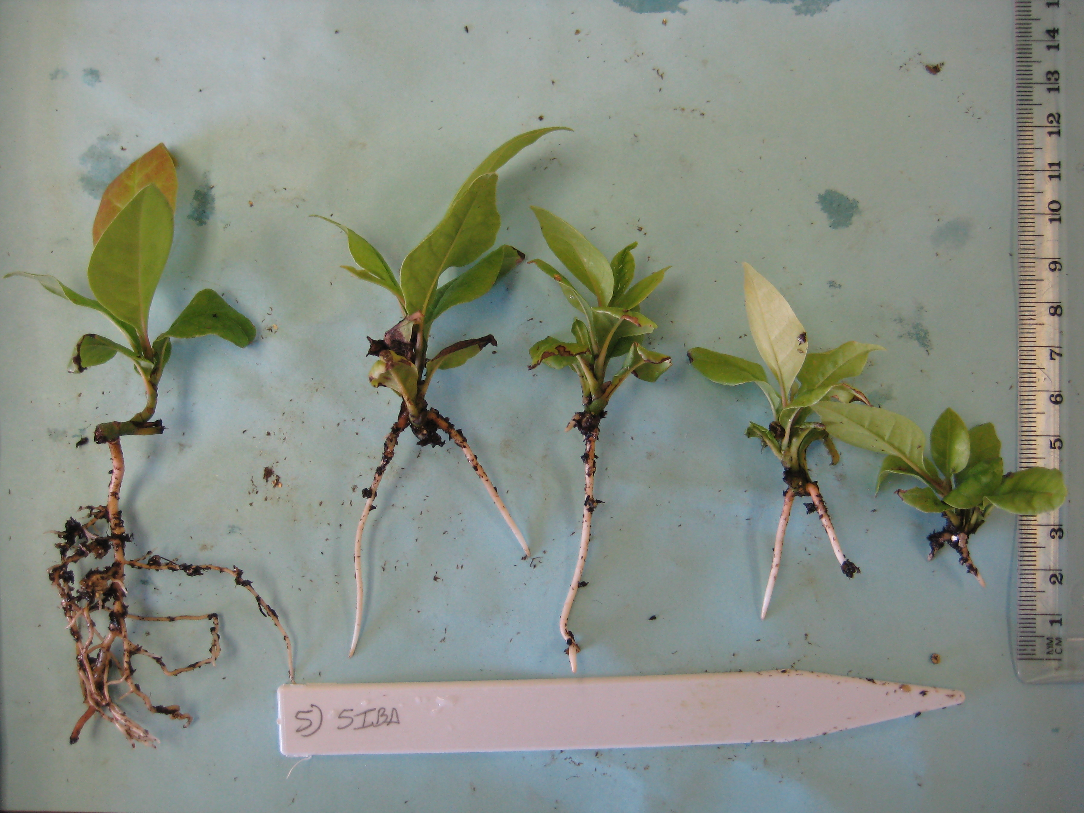 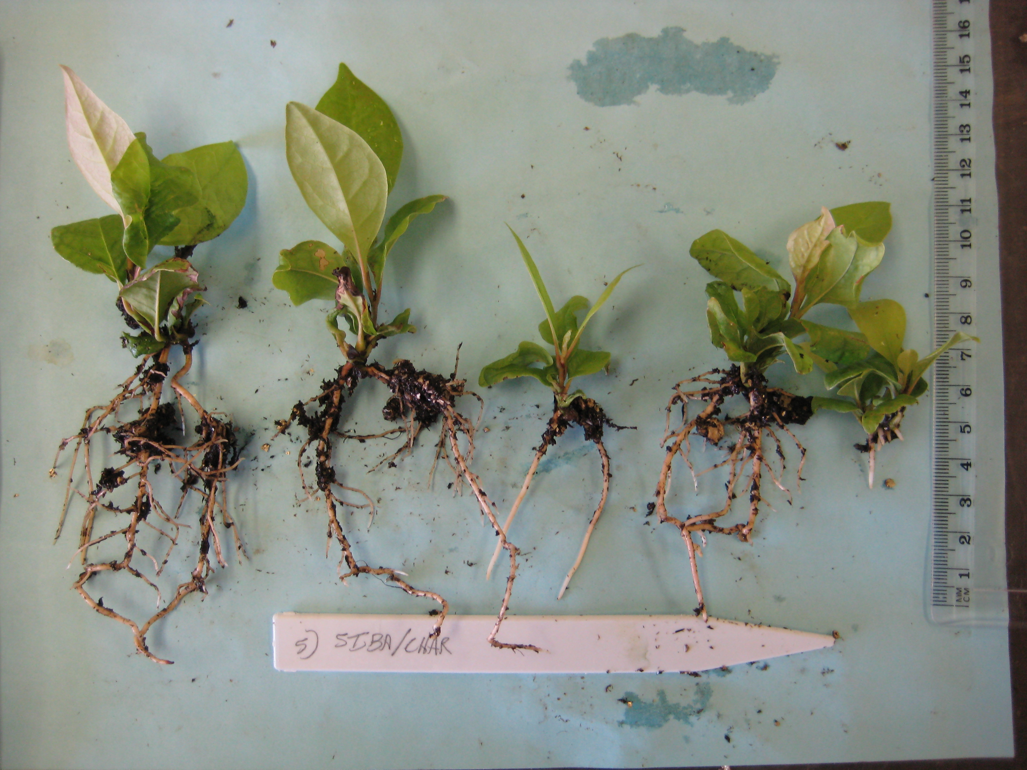

Figure 1: *Ex vitro* rooting and growth of *Magnolia* ‘Ann’ microcuttings 6 weeks after treatment *in vitro* with (Top) 5 µm IBA; and (Bottom) 5 µm IBA plus AC. When AC was incorporated *in vitro*, across all treatments, roots were more frequent, more lateral roots were present, and more leaves were produced *ex vitro.*  Scale divisions are in centimeters.